March 11, 2011, 5:17 p.m. EST

Quake toll rises; Japan sets nuclear emergency

At least 1,000 killed in Japan, some damage, 1 missing in California
By Lisa Twaronite, Polya Lesova and Benjamin Pimentel, MarketWatch
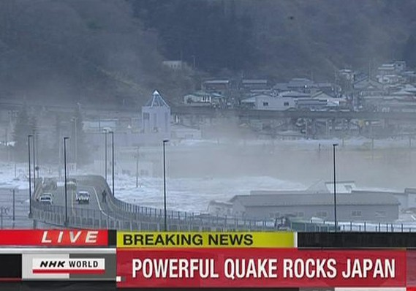
Reuters
A tsunami carries buildings (bottom, right) across waters in port city of Kamaishi.
SAN FRANCISCO (MarketWatch) — Japan’s most powerful earthquake in more than 100 years killed at least 1,000 people and triggered rising radiation levels at one of the nation’s several nuclear-power plants, according to reports Friday.
The quake also triggered a tsunami that also caused minor damage some 5,000 miles across the Pacific Ocean in Oregon and California where the U.S. Coast guard was searching for a person who was swept out to sea.
The 8.9-magnitude earthquake struck at 2:46 p.m. local time near the east coast of Honshu, about 231 miles northeast of Tokyo, according to the U.S. Geological Survey. Numerous aftershocks followed.
The quake also spawned a devastating 30-foot-high tsunami that wrecked the country’s northeastern coast and set off a series of tsunami alerts across four continents. NHK broadcasted live images of the tsunami hitting Miyagi prefecture in the Sendai area, with rushing water engulfing farmland and ripping homes from their foundations.
Kyodo News in Japan said that at least 1,000 people have been confirmed dead so far, many in the city of Sendai. The death toll will likely rise as the damage in other areas is assessed.
The news agency also reported that radiation levels were increasing at a damaged nuclear-power plant that was having troubles cooling after the quake.
Data from the U.S. Geological Survey showed the quake was the strongest to hit Japan in at least a century.
Prime Minister Naoto Kan said the earthquake “has resulted in tremendous damage across a wide area, centered on the Tohoku district.”
“I extend my heartfelt sympathy to those who have suffered,” he said in a statement.
A portion of Japan’s nuclear-power facilities automatically stopped their operations, Kan said. “At present, we have no reports of any radioactive materials or otherwise affecting the surrounding areas,” he said.
But Japanese authorities declared a state of nuclear emergency Friday evening.
The government ordered the evacuation of 3,000 residents within a two-mile radius of a nuclear-power plant in Fukushima Prefecture, while residents living between two to six miles away have been told not to go outside.
Kyodo News reported that the radiation level is rising in the plant amid concerns over the cooling system of one of its reactors.
According to several reports, the U.S. Air Force launched an emergency operation to deliver a special coolant to a nuclear plant damaged in the quake.
“We just had our Air Force assets in Japan transport some really important coolant to one of the nuclear plants,” Secretary of State Hillary Clinton said at a meeting earlier Friday, the reports said.
U.S. President Barack Obama said his nation stands ready to help the Japanese people “in this time of great trial.”
The quake sent thousands into the streets and hit transportation networks across Japan. In Tokyo, buildings shook and cellular-phone networks were overwhelmed, as people desperately tried to reach loved ones. The Tokyo Electric Power Company said that roughly 4.05 million households were without electricity in the Miyagi service area.
After the earthquake, a widespread tsunami warning was issued for numerous countries and territories across the Pacific, including Hawaii, parts of the U.S. West Coast, Russia, Taiwan and Chile.

Earthquake rocks Japan
Firsthand accounts of the 8.9-magnitude earthquake that struck Japan on Friday.
In the U.S., strong waves hit Hawai and California where the U.S. Coast Guard said it was searching for a person who was swept out to sea near Klamath River.
In Crescent City on the Northern California coast, waves caused serious damage to nearly three dozen vessels and area docks. Vessels were also pulled from their moorings in the harbor at Santa Cruz, south of San Francisco.
No serious damage or injuries were reported in the San Francisco and Los Angeles areas, although tsunami alerts prompted closure of beaches and coastal roads.
In Oregon, four people were rescued from the water, according to an Associated Press report. One man was found on a commercial vessel, but authorities said it appeared to be from natural causes, the report also said.
In central Tokyo, the quake caused glass to fall out of the windows of some older buildings and construction cranes to teeter violently.
Streets in the financial district of Otemachi and the government district of Kasumigaseki were filled with people evacuated from office buildings, unable to return home because subway services stopped.
Meanwhile, fires were reported at a major refinery owned by Cosmo Oil Co. /quotes/comstock/64e!5007 (JP:5007 282.00, -8.00, -2.76%) in Chiba, northeast of Tokyo, according to local media reports. JX Nippon Oil & Energy Corp., another refiner, halted operations at its refineries in three cities, including Sendai, where the airport was flooded after the tsunami hit. Another fire was reported at JFE Holdings Inc.’s /quotes/comstock/64e!5411 (JP:5411 2,493, -10.00, -0.40%) steel plant in Chiba.
Japan’s Nikkei Stock Average /quotes/comstock/64e!i:ni225 (JP:NI225 10,254, -179.95, -1.72%) fell after news of the earthquake circulated, ending 1.7% lower.
The Japanese currency rose against the U.S. dollar Friday, rebounding from an earlier selloff, as investors gauged the quake’s likely economic impact and effects on currency flows. Read more about the yen’s rebound.
Lisa Twaronite is MarketWatch's Tokyo bureau chief. Polya Lesova is chief of MarketWatch’s London bureau. Benjamin Pimentel is a MarketWatch reporter based in San Francisco.

http://www.marketwatch.com/story/powerful-earthquake-shakes-japan-2011-03-11

